Student Handout
The Carbon Cycle and Photosynthesis

Phenomenon: The Biosphere 2 Experiment

The carbon cycle is a complex process that occurs within the biosphere, involving the exchange of carbon dioxide (CO₂) between living organisms and the environment, and influencing global carbon levels and climate dynamics. During the Biosphere 2 experiment, the biosphere acted as a closed system to study the carbon cycle by simulating the exchange of carbon dioxide (CO₂) between the atmosphere, plants, and organisms.

Watch the Biosphere 2 YouTube video (tinyurl.com/biospherevideo) and answer the following questions:
- Why was the project named "Biosphere 2" instead of "Biosphere 1"?
______________________________________________________________________________________________________________________________________________________________________________________________________________________________

- What would plants and animals need to survive in a closed space like Biosphere 2?
______________________________________________________________________________________________________________________________________________________________________________________________________________________________

Carbon Cycle: Short-Term Cycle vs. Long-Term Cycle

Complete the sentences as you go over the slide deck.

The short-term carbon cycle involves the ______________ of carbon dioxide (CO₂) between the atmosphere, land, and oceans through processes like photosynthesis and respiration. It regulates CO₂ levels on a relatively ____________ timescale. In contrast, the long-term carbon cycle operates over _____________ timescales, involving processes such as _____ _________, ____________, and _____________________. It regulates the long-term carbon balance on Earth, impacting climate change dynamics over centuries and beyond.

Short-term carbon cycle: photosynthesis and cellular respiration (model)

Photosynthesis: Photosynthesis is the process by which plants convert sunlight, carbon dioxide, and water into glucose and oxygen.

Creating a Model:
- Draw a preliminary model of what you think photosynthesis looks like.

Model
Explanation

Watch the What is Photosynthesis? YouTube video (tinyurl.com/whatisphotosynthesis)

Revising the Model
- Revise your previous model after watching the above video. Be sure that your model explains how photosynthesis works at the molecular level.

Model
Explanation

- Watch the Relationship between Photosynthesis and Cellular Respiration YouTube video (tinyurl.com/cellrespirationvideo) and write a paragraph explaining how photosynthesis and cellular respiration relate. _________________________________________________________________________________________________________________________________________________________________________________________________________________________________________________________________________________________________________________________________________________________

Long-term Carbon Cycle: Cycling of Carbon Activity

Using PBS Learning: Carbon Dioxide and the Carbon Cycle
- Open the interactive carbon cycle model (tinyurl.com/carboncyclemodel). Complete the table with information about carbon cycle reservoirs by clicking on each blue box.

 | How many gigatons of carbon are in this reservoir? | Describe this reservoir.
Fossil Fuel
Ocean
Atmosphere
Land Biomass
Rocks

- Access the interactive model and navigate to the "CO₂ and the Atmosphere" tab.
  - Observe the image and the accompanying information it contains. Then, select the "Present Day" option to explore the updated information. Describe the differences between 300 years ago and today according to the image.
________________________________________________________________________________________________________________________________________________________________________________________________________________________________________________________________________________________________________
__________________________________________________________________________

  - After selecting the "View Chart" option on the right-hand side, you can see that three centuries ago the inflow of CO₂ into the atmosphere was balanced by the outflow of CO₂ from the atmosphere. Now, click “Present Day” and review the information on the chart. Answer the following questions:
    - How many gigatons of CO₂ go into the atmosphere from human activity annually?
____________________________________________________________________________________________________________________

    - How many gigatons does CO₂ increase in the atmosphere each year?
____________________________________________________________________________________________________________________

Measuring CO₂ in the atmosphere

Why is it important to measure CO₂?
________________________________________________________________________________________________________________________________________________________________________________________________________________________________________________________________________________________________________
____________________________________________________________________________________________________________________________________________________
__________________________________________________________________________

How can we measure and monitor CO₂ in the atmosphere?
______________________________________________________________________________________________________________________________________________________________________________________________________________________________
____________________________________________________________________________________________________________________________________________________
__________________________________________________________________________
__________________________________________________________________________

Observing Patterns in: “Watching Earth Breathe”

As you watch the video, you will answer the following questions:
- In the Watching Earth Breathe the Seasonal Vegetation Cycle and Carbon Dioxide YouTube video (http://tinyurl.com/earthbreathe), how does NASA measure CO₂ concentrations?
____________________________________________________________________________________________________________________________________________________
__________________________________________________________________________

- In general, which hemisphere experiences a greater change in CO₂ levels throughout the year: the Northern or Southern hemispheres?
____________________________________________________________________________________________________________________________________________________
__________________________________________________________________________

- Is the Earth “breathing” video related to the short-term or long-term carbon cycles?
____________________________________________________________________________________________________________________________________________________
__________________________________________________________________________

- Explain the patterns you observed in the video as they relate to CO₂ and photosynthesis.
____________________________________________________________________________________________________________________________________________________
__________________________________________________________________________

Applying this lesson to the Initial Phenomenon (Biosphere 2 Experiment)

- Use what you have learned to improve your response from Page 1 Q2: What would plants and animals need to survive in a closed space like Biosphere 2?
__________________________________________________________________________
____________________________________________________________________________________________________________________________________________________
__________________________________________________________________________
__________________________________________________________________________
____________________________________________________________________________________________________________________________________________________
__________________________________________________________________________

- Is Biosphere 2 an example of a short-term or long-term carbon cycle?
__________________________________________________________________________
__________________________________________________________________________

- Look at your multiyear CO2 time-series plot that you created in the Exploration Google Colab notebook (pasted below). This plot is for California. In the graph below, sketch the curve that you’d expect if you were monitoring CO2 in Buenos Aires (and include estimate x and y values).
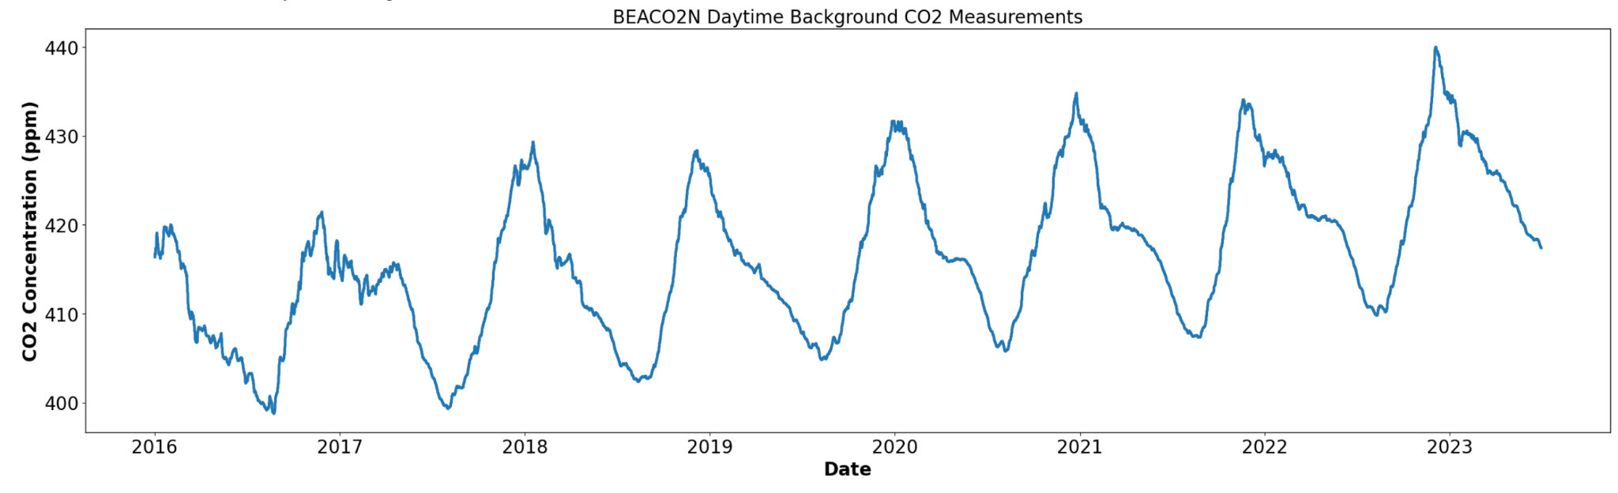

year
CO₂ Concentration
San Francisco Area
Buenos Aires

Time

